Chapter 4 – Digital Transmission (Forouzan).

1. Digital Transmission (5 Marks)
Definition:
Digital transmission is the transfer of digital data (bitstream or digitized analog signal) over a communication channel.
Communication Channels:
- Copper wires
- Optical fibers
- Wireless links
- Storage media
- Computer buses
Signal Representation:
Data is represented as electromagnetic signals such as:
- Electrical voltage
- Radio waves
- Microwave
- Infrared signals
Advantages:
- More reliable than analog transmission
- Resistant to noise
- Supports error detection and correction

Signal Level vs. Data Level (Comparison Table – Exam Standard)
Basis of Comparison | Signal Level | Data Level
Definition | Number of distinct voltage (or amplitude) values allowed in a signal. | Number of different symbols used to represent data.
Concerned With | Physical representation of the signal. | Logical representation of data (bits or symbols).
Represents | Voltage, current, or signal amplitude. | Binary digits (0,1) or multilevel data symbols.
Relation to Transmission | Determines how the signal appears on the transmission medium. | Determines how many bits are carried per symbol.
Example (Binary) | 2 signal levels → +V and −V | 2 data levels → 0 and 1
Example (Multilevel) | 3 signal levels (−V, 0, +V) | May still represent 2 data levels
Formula Relation | Used in Bit Rate formula through L (data levels). | L = number of data levels in BitRate = PulseRate × log₂L
Exam Point | Physical characteristic of line coding. | Logical meaning of transmitted information.

Pulse Rate vs. Bit Rate (Comparison Table – 5 Marks)
Basis of Comparison | Pulse Rate | Bit Rate
Definition | Number of pulses transmitted per second. | Number of bits transmitted per second.
Unit | Pulses per second (baud) | Bits per second (bps)
Represents | Speed of signal changes on the transmission medium. | Speed of actual data transmission.
Depends On | Pulse duration (minimum time to send one symbol). | Pulse rate and number of data levels (L).
Formula | Pulse Rate = 1 / Pulse Duration | Bit Rate = Pulse Rate × log₂L
When L = 2 | Pulse rate = Bit rate | Because log₂2 = 1
When L > 2 | Pulse rate < Bit rate | Because one pulse carries multiple bits

Example (Important for Exam)
If pulse duration = 1 ms and L = 4
Pulse Rate = 1 / 0.001 = 1000 pulses/sec
Bit Rate = 1000 × log₂4 = 1000 × 2 = 2000 bps
4. Unipolar Encoding (5 Marks)
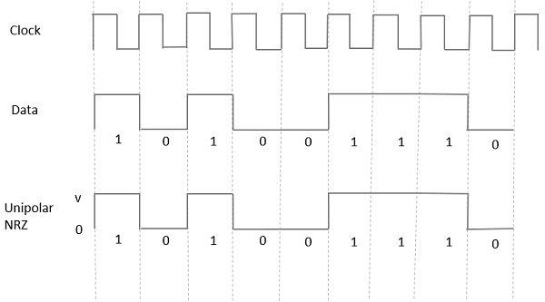
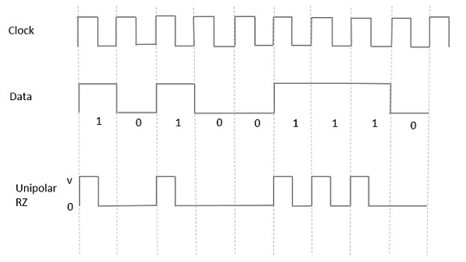

Definition:
Unipolar encoding uses only one voltage level to represent data.
Representation:
- Binary 1 → High voltage
- Binary 0 → No voltage
Advantages:
- Simple implementation
Disadvantages:
- Large DC component
- Poor synchronization
- Not suitable for long-distance communication

5. Polar Encoding (5 Marks)
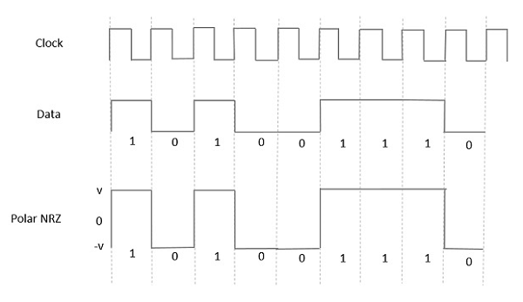

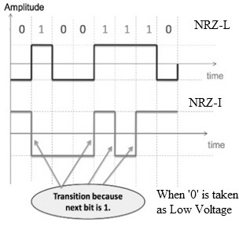
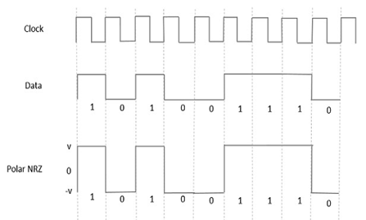
Definition:
Polar encoding uses two voltage levels: positive and negative.
Types:
- NRZ
- RZ
- Manchester
- Differential Manchester
Advantages:
- Eliminates DC component
- Better synchronization than unipolar

6. NRZ (Non-Return to Zero) (5 Marks)
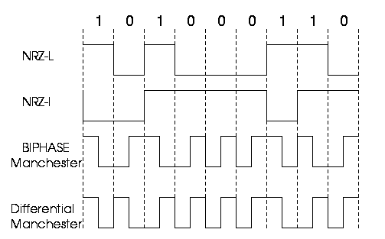

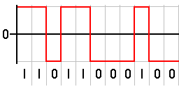
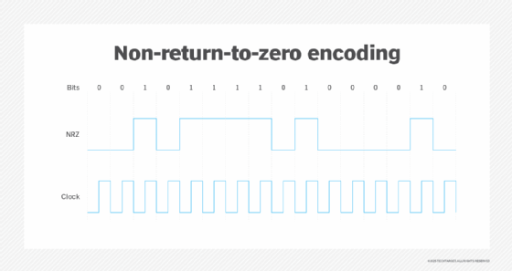
Definition:
NRZ uses two voltage levels to represent binary values.
Representation:
- Positive voltage → 0
- Negative voltage → 1
Advantages:
- Simple
- Efficient bandwidth usage
Disadvantages:
- Synchronization problem with long identical bits

7. RZ (Return to Zero) (5 Marks)

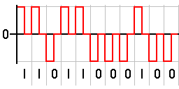
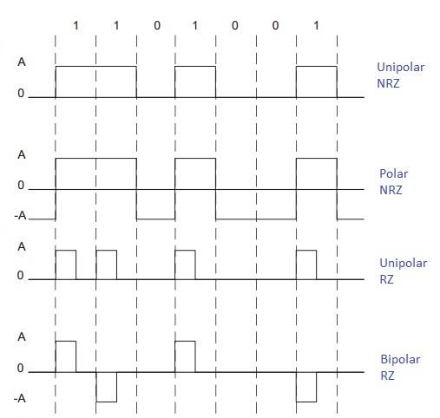
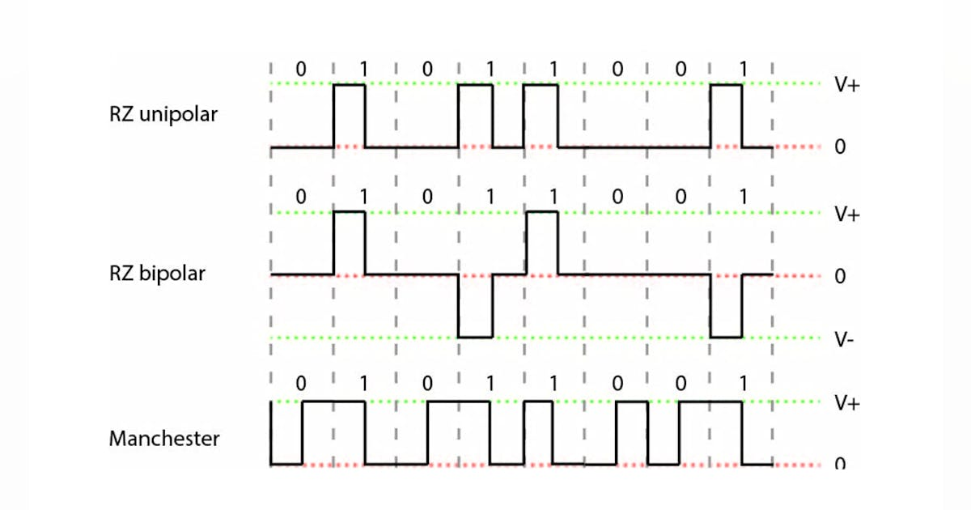
Definition:
Signal returns to zero between each bit.
Representation:
- Bit 1 → Positive → Zero
- Bit 0 → Negative → Zero
Advantages:
- Ensures synchronization
Disadvantages:
- Requires 3 amplitude levels
- Needs more bandwidth

8. Manchester Encoding (5 Marks)
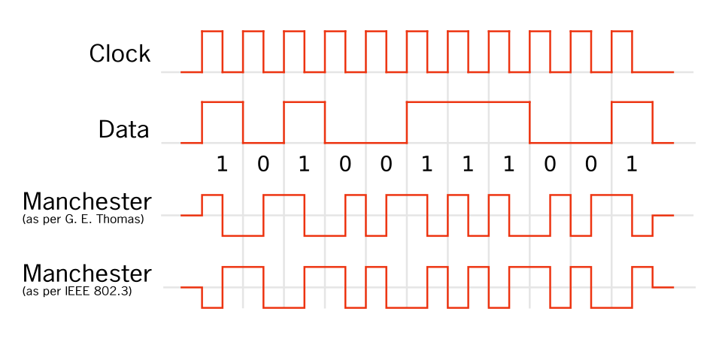
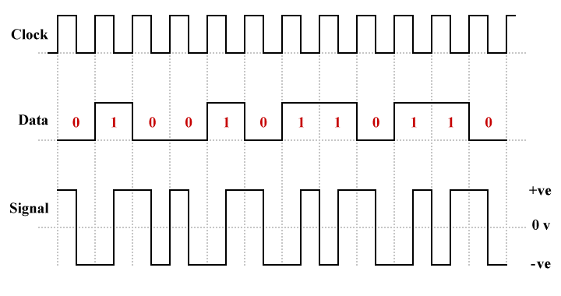

Definition:
Self-synchronizing encoding with a transition in the middle of each bit.
Representation:
- 1 → High to Low
- 0 → Low to High
Advantages:
- No DC component
- Easy clock recovery
Disadvantages:
- Requires double bandwidth compared to NRZ
Application: Used in Ethernet networks.

9. Differential Manchester (5 Marks)
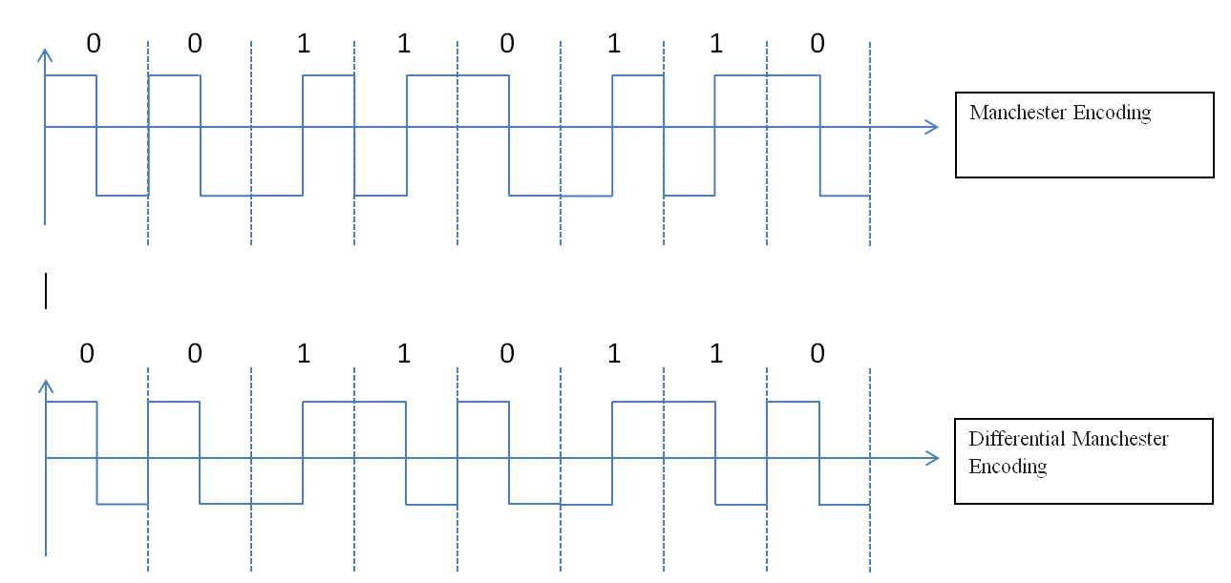
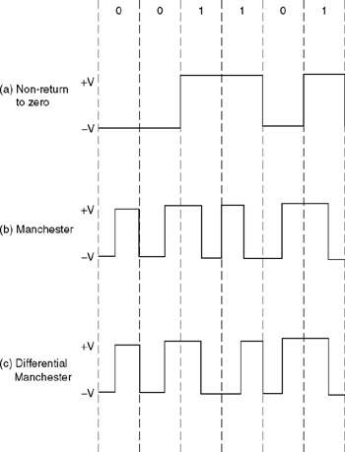
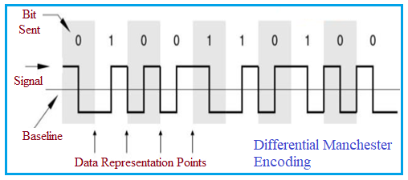
Definition:
Always has a transition in the middle of the bit interval.
Representation:
- Transition at beginning → 0
- No transition at beginning → 1
Advantages:
- Self-synchronizing
- Immune to polarity inversion
Application: Used in Token Ring networks.

10. Bipolar Encoding (5 Marks)
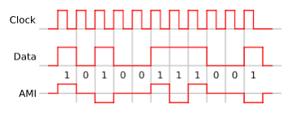
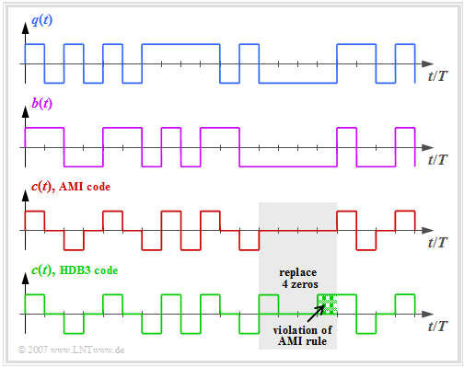
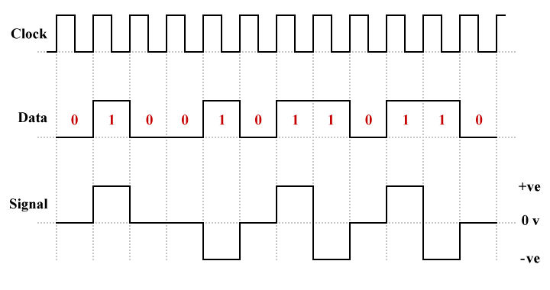

Definition:
Uses three voltage levels: positive, negative, and zero.
Types:
- AMI (Alternate Mark Inversion)
  - 0 → Zero voltage
  - 1 → Alternating + and −
- Pseudoternary
  - 1 → Zero voltage
  - 0 → Alternating + and −
Advantages:
- Reduces DC component
Disadvantages:
- Synchronization problem with long sequence of 0s

11. Pulse Amplitude Modulation (PAM) (5 Marks)
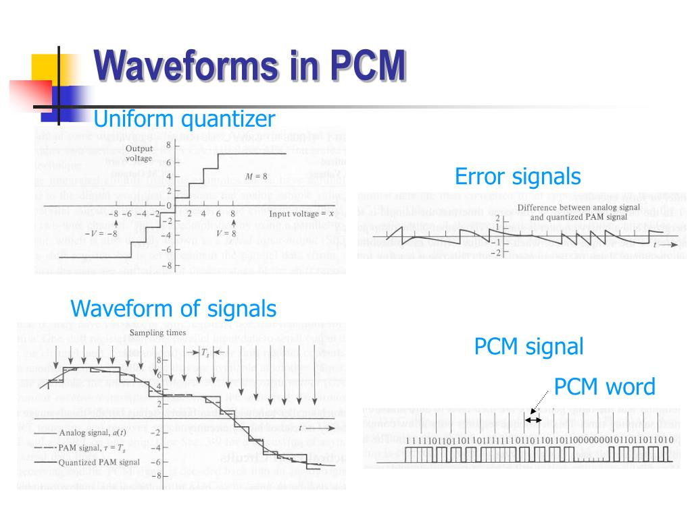

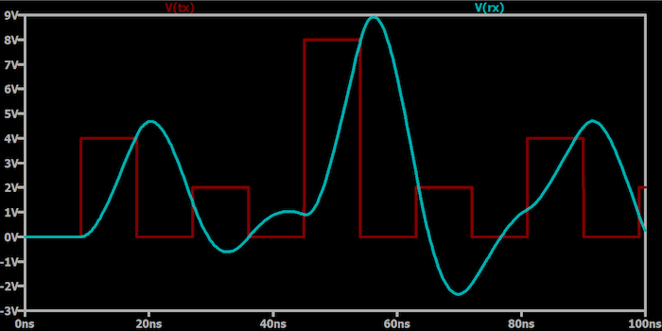
Definition:
PAM is an analog-to-digital conversion method where sampled signal amplitudes are represented by pulses.
Process:
- Sampling
- Quantization
- Encoding (in PCM)
Note:
PAM is the first step in Pulse Code Modulation (PCM).

Parallel vs Serial Transmission (5 Marks – Exam Standard)
Basis of Comparison | Parallel Transmission | Serial Transmission
Definition | Multiple bits are transmitted simultaneously over multiple channels. | Bits are transmitted one after another over a single channel.
Number of Wires | Requires multiple wires (equal to number of bits). | Requires only one communication line.
Speed | High speed (short distance). | Slower than parallel (but efficient for long distance).
Cost | Expensive due to multiple wires. | Cheaper and simpler.
Distance | Suitable for short distances. | Suitable for long distances.
Example | Used inside computer (CPU to memory, system bus). | Used in network communication, USB, internet data transfer.
Interference | More prone to crosstalk and signal skew. | Less interference problem.

Short Conclusion (Write in Exam)
Parallel transmission sends multiple bits at the same time using multiple wires and is used for short distances. Serial transmission sends bits sequentially over a single line and is suitable for long-distance communication.

Asynchronous vs Synchronous Transmission (5 Marks – Exam Standard)
Basis of Comparison | Asynchronous Transmission | Synchronous Transmission
Definition | Data is transmitted one byte at a time with start and stop bits. | Data is transmitted as a continuous stream of bits without start/stop bits.
Synchronization | Synchronization at byte level. | Synchronization at frame or block level.
Start/Stop Bits | Each byte has 1 start bit (0) and 1 or more stop bits (1). | No start/stop bits used.
Gap Between Data | May have gaps between bytes. | No gaps between bits.
Efficiency | Less efficient (extra bits added). | More efficient (no extra start/stop bits).
Complexity | Simple implementation. | Complex, requires precise clock synchronization.
Example | Keyboard input, serial port communication. | High-speed communication, LAN, WAN.

Short Conclusion (Write in Exam)
Asynchronous transmission sends data byte by byte with start and stop bits, making it simple but less efficient. Synchronous transmission sends a continuous stream of bits without start/stop bits, making it faster and more efficient but requiring proper clock synchronization.

